“Київський фаховий коледж зв’язку”

Циклова комісія комп’ютерної та програмної інженерії

**ЗВІТ ПО ВИКОНАННЮ**

**ЛАБОРАТОРНОЇ РОБОТИ №4**

з дисципліни: «Операційні системи»

**Тема: «Команди Linux для управління процесами»**

Виконав(ла/ли) студент(ка/и)

групи КСМ-23А

Команда КГК:

Корольов Є.Ю.,

Горохов Д.С. та

Коваленко С.О.

Перевірила викладач

Сушанова В.С.

Київ 2024

**Мета роботи:**

1. Отримання практичних навиків роботи з командною оболонкою Bash.
2. Знайомство з базовими командами для управління процесами.

**Матеріальне забезпечення занять**

1. ЕОМ типу IBM PC.

2. ОС сімейства Windows та віртуальна машина Virtual Box (Oracle).

3. ОС GNU/Linux (будь-який дистрибутив).

4. Сайт мережевої академії Cisco netacad.com та його онлайн курси по Linux.

**Завдання для попередньої підготовки**

***Готував матеріал студент Корольов Є.***

1. Прочитайте короткі теоретичні відомості до лабораторної роботи та зробіть невеличкий словник базових англійських термінів з питань класифікації ОС.

|  |  |
| --- | --- |
| Термін англійською | Термін українською |
| **Operating System** | Операційна система |
| **Kernel** | Ядро |
| **User Interface (UI)** | Інтерфейс користувача (ІК) |
| **Command-Line Interface (CLI)** | Інтерфейс командного рядка |
| **Graphical User Interface (GUI)** | Графічний інтерфейс користувача (ГІК) |
| **Multitasking** | Багатозадачність |
| **Single-tasking** | Однозадачність |
| **Multithreading** | Багатопоточність |
| **Real-time Operating System** | Операційна система реального часу |
| **Memory Management** | Управління пам'яттю |
| **Virtual Machine** | Віртуальна машина |

1. На базі розглянутого матеріалу дайте відповіді на наступні питання:
   1. Які команди для моніторингу стану процесів ви знаєте. Як переглянути їх можливі параметри?

* ps

To view possible parameters you need write| man ps or ps –help|

* top

After start working command you should press “h” or write command “man top”

* glances

glances –help or man glances

* 1. Чи може команда ps у реальному часі відслідковувати стан процесів?

No, that command cant follow in real time. For this we use command “top”.

* 1. За якими параметрами можливе сортування процесів в команді top? Як переключатись між ними?

After running the top command, press the corresponding key:

P — sort by CPU usage.

M — sort by memory usage.

T — sort by execution time.

N — sort by PID.

V — sort by virtual memory usage.

* 1. Які команди для завершення роботи процесів ви знаєте?

Combination Cntr+Z

Comand kill

Comand killall

**Хід роботи**

***Готував матеріал студент Горохов Д.***

1. Робота в графічному режимі в ОС сімейства Linux:.
   1. Запустіть віртуальну машину VirtualBox, ознайомтесь з її основними можливостями, прочитайте довідку по роботі з нею.
   2. Як вивести вміст директорії /proc? Де вона знаходиться та для чого призначена? Охарактеризуйте інформацію про її вміст?

To list the contents of the /proc directory, we need to use ls /proc.

The /proc directory is a virtual filesystem in Linux that provides real-time information about the system and running processes. It’s located at the root (/) of the filesystem and doesn't hold actual files but represents system data.

**Purpose:**

* **Process info**: Contains directories named by process IDs (PIDs), each holding details like memory usage, open files, and status.
* **System info**: Files like cpuinfo, meminfo, and uptime provide hardware and system details.

**Key Files:**

* 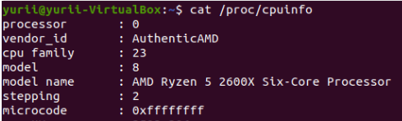**/proc/cpuinfo**: CPU details.
* 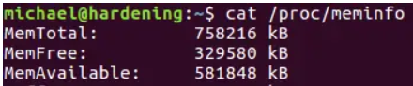**/proc/meminfo**: Memory usage.
* 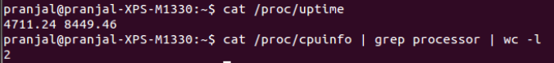**/proc/uptime**: System uptime.
* 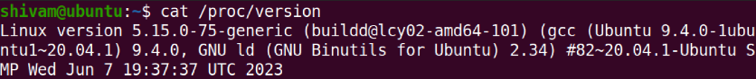**/proc/version:** Information about each running process.
  1. Як вивести інформацію про поточні сеанси користувачів. Якою командою це можна зробити?

To view information about current user sessions on a Linux system, you can use the who command. This command displays a list of all users currently logged in, along with details about their sessions.

**Using the who command:**

1. **Open the Terminal:** Access your system's terminal emulator.
2. **Enter the Command:** Type who and press Enter.

This will output a list of logged-in users, showing details such as their usernames, terminal names, and login times.

**Additional Options:**

* **Detailed Information:** For more comprehensive details, use the -a option.

This includes information like the system's boot time, current runlevel, and user logins.

* **Count of Logged-In Users:** To display the number of users currently logged in, use who -q.

This provides a quick count of active user sessions.

**Alternative Commands:**

* **Command:** The w command offers a summary of current user sessions, including details about their processes and system load.

This displays who is logged in and what they are doing, providing insights into system activity.

* **Command:** The users command lists all users currently logged in, in alphabetical order.
  1. Які дії можна зробити в терміналі за допомогою комбінацій Ctrl + C, Ctrl + D та Ctrl + Z?
     + **Ctrl + C**:
* **Action**: Terminates the current running process or command.
* **Use**: Useful when you want to stop a command that's taking too long or behaving unexpectedly.
  + - **Ctrl + D**:
* **Action**: Sends an EOF (End of File) signal.
* **Use**: Often used to log out of a terminal session or to signal the end of input in commands like cat or ftp.
  + - **Ctrl + Z**:
* **Action**: Suspends (pauses) the current running process and places it in the background.
* **Use**: Allows you to pause a process, which you can later resume with the fg (foreground) or bg (background) commands.
  1. Чим відрізняється фоновий процес від звичайного. Де вони використовуються?

**Foreground Process**:

* **Definition**: A process that interacts directly with the user through the terminal or user interface.
* **Characteristics**: The terminal is actively occupied by this process, and it waits for the user to input commands or interact with the program.

**Background Process**:

* **Definition**: A process that runs in the background without requiring user interaction.
* **Characteristics**: The terminal is not blocked, allowing the user to continue using it for other commands. These processes run independently of user input after being started.

In Linux, you can send a process to the background by appending & to the command (e.g., sleep 100 &) or using Ctrl + Z and then the bg command to resume it in the background.

* 1. Опишіть наступні команди та поясніть що вони виконують – команда jobs, bg, fg.

**jobs**:

* **Description**: Displays a list of all jobs (processes) that are running or paused in the current shell session.
* **What it does**: It shows the status of jobs, indicating if they are running in the background or have been suspended. Each job is assigned a unique job ID.

**bg** (Background):

* **Description**: Resumes a suspended job by running it in the background.
* **What it does**: If a job is paused (suspended with Ctrl + Z), bg sends it to the background, allowing it to continue running while freeing up the terminal for other commands.
* **fg** (Foreground):
* **Description**: Brings a background or suspended job to the foreground.
* **What it does**: It resumes the selected job and makes it the active process in the terminal, requiring user input.
  1. Якою командою можна переглянути інформацію про запущені в системи фонові процеси та задачі?

**jobs**:

* Shows the list of background jobs in the current terminal session.

**ps** (Process Status):

* Displays information about all running processes, including background ones. You can use options to list specific processes.

**top**:

* Displays a real-time view of all active processes, including background ones.

**htop**:

* A more user-friendly version of top, providing an interactive interface to monitor processes, including background tasks.
  1. Як призупинити фоновий процес, як його потім відновити та при необхідності перезапусти?

**Suspend a Background Process:**

* If a process is already running in the background, you can suspend it by using the kill command with the **STOP signal**: kill -STOP [PID]

We can also resume process with command: kill -CONT <PID>  
Where [PID] is the Process ID of the background task.

* If the process is running in the foreground, first suspend it with **Ctrl + Z**. This sends the process to the background in a paused state.

**Resume a Suspended Background Process:**

* To continue the suspended process in the background, use the bg command:

bg %[jobID]

This resumes the suspended process as a background job.

* To bring the suspended process back to the foreground, use the fg command:

fg %[jobID]

**Restart a Background Process:**

* If the process was stopped, and you want to restart it in the foreground:

fg %[jobID]

* If you want to restart it in the background:

bg %[jobID]

Where [jobID] is the job number obtained from the jobs command.

1. **Виконали студенти Горохов Д. та Корольов Є.**
   * + Запустіть термінал, та в командному рядку виконайте наступні дії для ознайомлення з роботою з процесами:
   1. 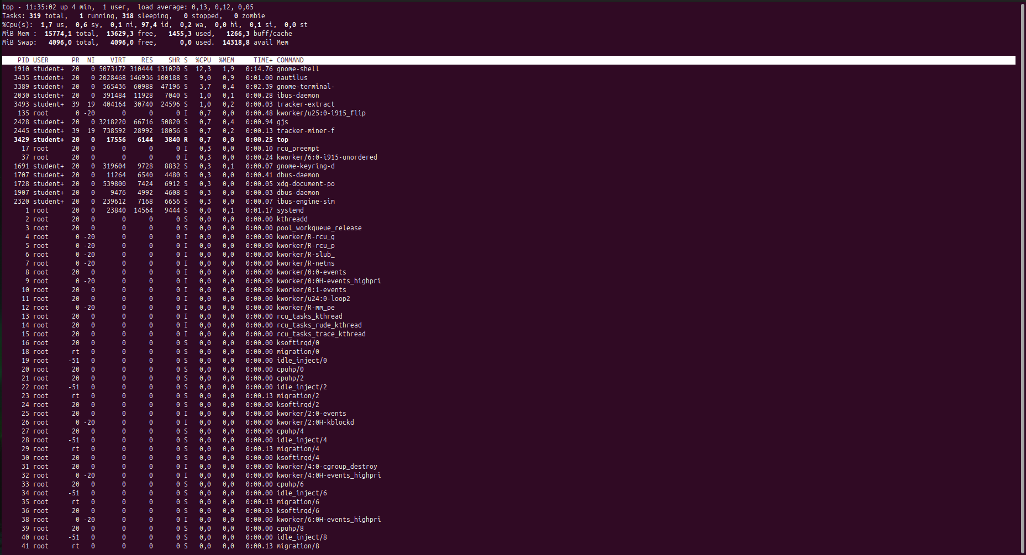запустіть команду top, проаналізуйте отриманий в цій команді результат та охарактеризуйте найбільш активні процеси у системі;

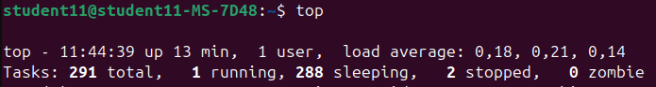Top is used to show the active Linux processes. In our case, the most active process is sleeping

* 1. призупинити виконання команди top (треба використати комбінацію клавіш);

Ctrl+Z or Ctrl+D

* 1. вивести інформацію про процеси за допомогою команди ps;

The 'ps' command has several common options, such as -e or -A which displays all processes on the system, including those from other users. The -f option shows the full format of the output, including more details about the processes like PPID, terminal, and user.

* 1. наведіть 5 прикладів з використанням різних параметрів команди ps(наприклад, вивести тільки системні процеси, вивести процеси конкретного користувача, вивести дерево процесів тощо). Опишіть, що саме роблять обрані Вами параметри:
     + 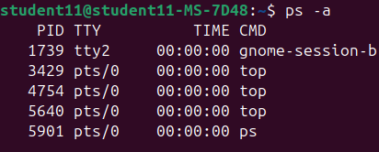ps -a(Shows all processes except session headers and processes without a terminal):
     + 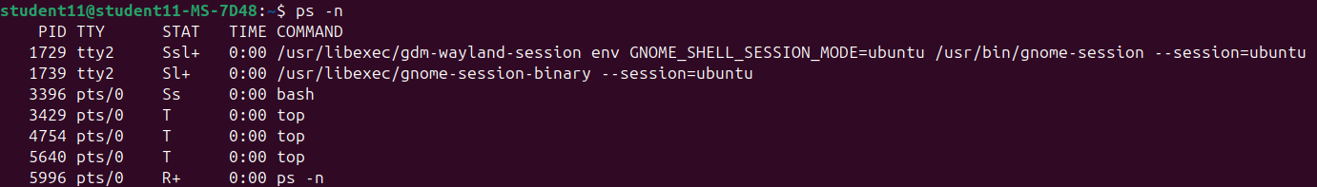ps -n(Shows the opposite of the specified parameters)
     + ps -C cmslist (Shows processes contained in the list cmdlist)
     + 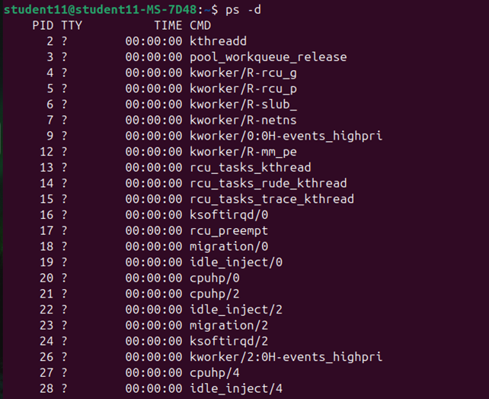ps -d (Shows all processes except session header)
     + 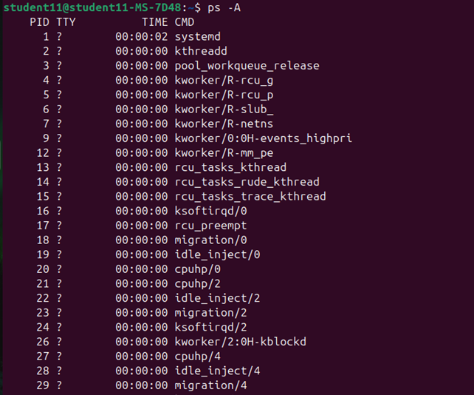ps -A (Shows all processes)
  2. Передивіться чи є у Вас запущені фонові процеси, які саме?

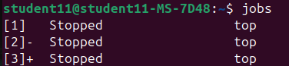To see the active background process, we can use the command jobs. Jobs - is show the active processes, in our case we closed three times top background.

* 1. Відновити виконання призупиненого фонового процесу спочатку у позиції “на передньому плані” (foreground), потім ще раз його призупинити, а потім відновити його виконання у позиції “на задньому плані” (background):

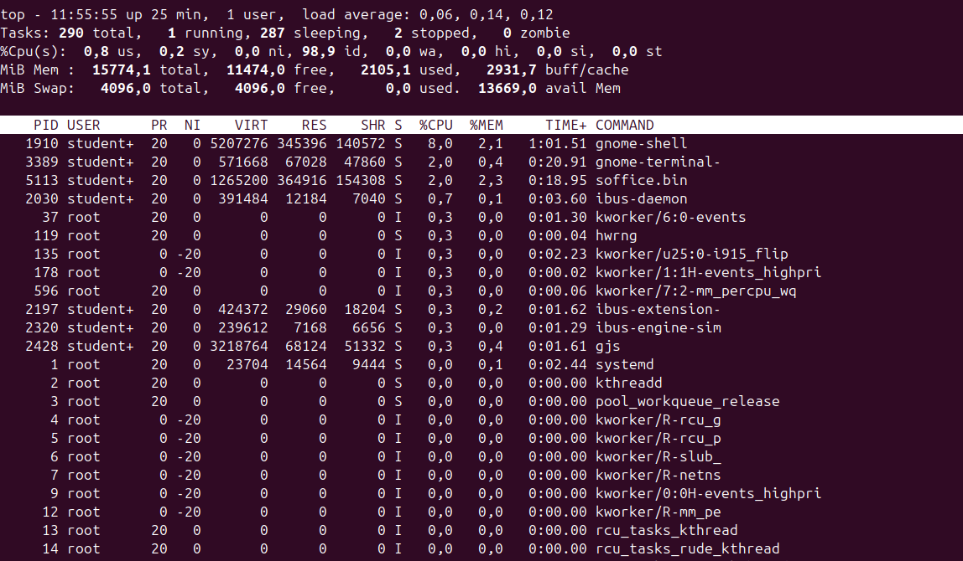command fg – foreground, which show us the process in the screen(Before we closed three processes, if we write fg 3(third process in jobs window), that start closed process)

**Suspend (Ctrl + Z)**: Suspend the process while it's in the foreground by pressing **Ctrl + Z**.

command bg – background, which show us the process out of the screen:

To terminate a background process, we can use the kill command (kill 1) or just stop it with pressing Ctrl + Z.

**Відповіді на контрольні запитання**

***Готував матеріал студентка Коваленко С.***

1. Information about processes is stored in the /proc/N directory, where N is the numeric process identifier. This directory contains various pseudo-files that contain information about the process itself and its associated environment.

2. 1.Use the ps or top command in Linux. For example, to get a list of processes with their memory usage.

2. Select three processes for which you want to analyze.

3. Compare the percentage of memory (%MEM) for each of the three processes to find the largest.

4. Determine the total amount of system memory, for example, by using the command.

5. If the processes use 10 MB, 20 MB, and 30 MB of memory and the total system memory is 100 MB, then:

The process with the highest utilization: 30 MB

Percentage:

(30/100)×100=30%

1. To get information about the hierarchy of parent processes, you can use the ps command or the pstree utility. The main directories and their purpose in the Linux system:

/ (Root): This is the initial directory that contains all other files and directories in the system.

/bin (Binary files): Contains the executable files (programs) needed for general use.

/boot: Contains boot files, such as the system kernel and the boot configuration file.

/dev (Devices): Contains files that represent devices on the system, such as terminals, printers, and other devices.

/etc (Configuration): Contains configuration files for various programs and system settings.

/home: User directories are usually located here.

/lib and /lib64 (Libraries): Contains system libraries used by programs at runtime.

/media and /mnt (External devices): Directories for mounting external devices such as USB drives, CD-ROMs, etc.

/opt (Optional Programs): Contains installed optional programs.

/proc (Processes): Contains information about running processes and system resources in the form of virtual files.

/root: The home directory of the root user.

/sbin (System binaries): Contains executable files used for system administration.

/tmp (Temporary files): Contains temporary files that are created while the system is running.

/usr (Secondary Resource): Contains data and programs that are used by many users.

/var (Variable data): Contains variable data such as logs, caches, database files, etc.

1. The top command displays information about processes in real time, updating the data at a certain interval.

The ps command displays a snapshot of the processes at the time of the command execution.

1. Htop is a process monitor written for GNU/Linux. It is intended to replace the standard top program. htop dynamically displays a list of system processes, the list is usually aligned with CPU usage. Unlike top, htop shows all processes in the system. It also shows the time of continuous operation, CPU and memory usage.

htop is often used in cases where the top utility is not enough, for example, when searching for memory leaks in processes.

1. iOS has a sophisticated memory management system that automatically monitors and adjusts the use of random access memory (RAM). It can offload background apps from memory if the system needs more resources. In iOS, the System Preferences screen allows you to view memory, battery, and data usage for each app. This lets users know which apps are using the most resources. Although iOS doesn't have a classic task manager, users can view running apps by double-clicking the Home button (for older models) or swiping up from the bottom of the screen (for newer models). This allows you to close apps that are not in use.
2. The iOS mobile operating system does not support terminal management of workflows in the traditional sense, as is possible with desktop operating systems such as Linux.
3. On iOS, the ability to install third-party apps to manage and monitor processes is limited due to Apple's security policy. However, some apps may provide certain functions for monitoring the system or providing information about processes.

Termius is an SSH client that allows you to connect to remote servers from your iOS device. You can use Termius to control processes on remote systems.

System Status is a system performance monitoring application. Although it does not allow you to manage processes, it provides information about resource utilization.

iSH is a Linux emulator that allows you to run the Alpine Linux shell on iOS. Although this application does not provide full access to system processes, it allows you to run some command utilities that provide basic information about the system.

**Висновки:**

In the course of the course “Linux Commands for Process Control”, the students gained practical skills in working with the Bash shell, which is an important tool for Linux users. Familiarization with the basic commands for process control made it possible to understand how to monitor and control the execution of processes in the system.

The skills gained during the course of the course allow you to effectively manage system resources, analyze the status of running programs, and, if necessary, stop or reprioritize processes. This knowledge is important for ensuring system stability and performance, as well as for solving problems related to resource overload.